EXTERNAL Xpress Application Overview with SLK

Date: 15/04/2025
SME(Discover) : Palla Nigam

History of Credit Cards - How the Credit Card Was Born – A Real-Life Story

Back in 1949, a man named Frank McNamara went out for dinner at a fancy restaurant in New York City with his wife and a friend. When it was time to pay the bill, he realized — he had forgotten his wallet at home! It was super embarrassing.

That moment made him think — "What if there was a way to pay without carrying cash all the time?"

So, the next year, in 1950, Frank teamed up with his friend Ralph Schneider, and they created something new — a card that people could use to pay at restaurants and pay the total bill later. They called it Diners Club.

At first, only a few restaurants accepted it, and only a few people used it. But soon, it became really popular, and thousands of people started using the card.

Even though it wasn’t exactly like today’s credit cards (you had to pay the full amount every month), it was the first step toward the credit cards we all use today.

- First Credit Card:
  - Diners Club International created the first-ever credit card in the world in 1950.
- Payment Networks:
  - The first few digits of a credit card tell you which payment network it belongs to:
    - 34 or 37 for American Express
    - 36 for Diners Club International
    - 4 for Visa
    - 5 for Mastercard
    - 6 for Discover
- Historical Milestones:
  - BankAmericard was the first general-purpose credit card in the US in 1958.
  - Barclaycard holds the distinction of being the first credit card issued by a British bank in 1966.
- Spending Habits:
  - On average, people in the US spend about $97 per transaction when using their credit cards.

Discover Financial Services Overview

Discover Global Network Components
Discover Financial Services is primarily an online bank with minimal physical presence—it operates without physical branches, except for one located in the U.S. In addition to its banking services, Discover also operates its own payment network, which sets it apart from many other financial institutions. This unique dual role—as both a bank and a payment network—gives Discover a distinctive position in the market, as very few companies globally offer both services under one roof.

When Discover initially launched, it operated primarily within the United States, and its payment network was limited to handling domestic transactions. However, in 2008, Discover aimed to expand globally. To achieve this, it acquired Diners Club International (DCI), a card network with a significant international presence. This acquisition allowed Discover to extend its global reach using DCI’s established network.

Another important part of Discover’s infrastructure is the Pulse network, which focuses on ATM and debit card transactions. All of Discover’s ATM and debit activity is processed through Pulse, making it a key component of its services. In contrast, Discover and Diners Club International primarily handle credit card transactions.

To summarize, Discover’s payment operations are grouped under the Discover Global Network (DGN), which consists of three main components:

- DN – Discover Network (U.S.-based credit card transactions)
- DCI – Diners Club International (global credit card network)
- Pulse – Pulse Network (ATM and debit transactions

Payment Services MANIC Model
Merchant <→ Acquirer <→ Network <→ Issuer <→ Cardholder
Merchant | Acquirer | Network | Issuer | Cardholder
- Provides goods and services to consumer  - Accepts card  Examples:  Best Buy  Amazon  Shell | - Provides payment services to merchant  - Routes transaction to network  - Settles fund with merchants and network  Examples:  First Data  Elavon | **This is us!**  - Switches transaction, the routing, between Acquirer and Issuer  - Sets pricing to Issuers/Acquirers  - Settles with Merchants/Issuers  Examples:  Discover Network  Diners Club International  PULSE  Visa  Mastercard | - Authorizes transaction  - Provides line of credit to card member  Examples:  Discover Bank  Synchrony Bank  Capital One  DCI Japan | - Purchases goods or services  Examples:  You

Transaction Cycle Overview:

1. Cardholder
- The individual who initiates a purchase using a credit or debit card.
- Example: A customer at a store or online platform.

2. Merchant
- Provides goods or services to the cardholder.
- Accepts card payments and initiates the transaction.
- Examples: Best Buy, Amazon, Shell

3. Acquirer
- The financial institution or payment processor associated with the merchant.
- Receives the transaction from the merchant.
- Forwards the transaction to the payment network.
- Examples: First Data, Elavon

4. Network
- Routes the transaction between the acquirer and the issuer.
- Performs key roles such as:
  - Authorization Routing – Facilitates ISO message flows between entities.
  - Settlement Processing – Manages the movement of funds across financial institutions.
  - Dispute Resolution – Acts as a central authority to resolve payment disputes.
- Examples: Discover Network, Diners Club International, Visa, MasterCard, PULSE

5. Issuer
- The cardholder's bank or financial institution.
- Authorizes the transaction.
- Provides a line of credit or debits the cardholder's account.
- Examples: Discover Bank, Capital One, Synchrony Bank, DCI Japan

Payment Services MANIC Model (Authorization and Settlement Process – Overview)
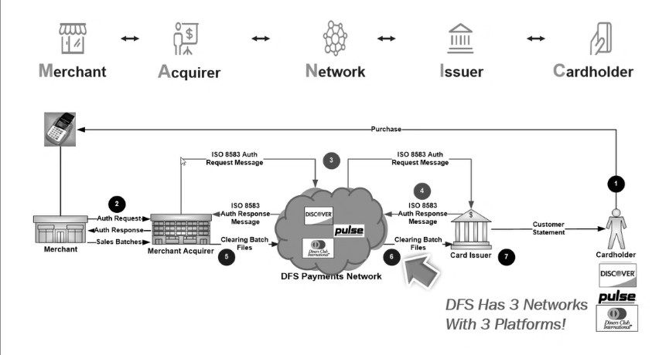When user make a transaction as a cardholder at a merchant place using various methods like POS machines, online platforms, digital wallets, or smartwatches, an ISO message is generated from the merchant's terminal and sent to their acquirer (step 2). This request then goes to a payment network (step 3), which routes it to your issuing bank based on your card's network (e.g., Discover, MasterCard). The issuing bank decides whether to approve or decline your transaction based on its business logic and sends its decision back through the same route (steps 4-6). You receive confirmation via a receipt from the POS machine indicating approval or decline of your transaction.

Authorization only blocks funds but does not transfer them immediately; actual fund transfer happens during settlement when both acquirers and issuers submit batch files for reconciliation by networks like DFS (Discover Financial Services), ensuring amounts match before transferring funds.

Authorization and Settlement Process – Overview
This diagram explains the complete flow of a card payment transaction, covering both authorization and settlement processes. This is fundamental to understanding how credit and debit card payments work behind the scenes.

Step-by-Step Explanation
- Initiation by the Cardholder:
A customer (Cardholder) initiates a transaction by making a purchase at a merchant location. This could happen in several ways—via a POS (Point-of-Sale) terminal, online platforms, digital wallets, or even smartwatches.
- Merchant to Acquirer:
Once the transaction is initiated, an ISO message is generated from the merchant’s terminal. This message is then sent to the Acquirer, which is the financial institution or bank where the merchant holds its account.
- Acquirer to Network:
The Acquirer forwards the ISO message to the appropriate Payment Network (e.g., Discover, Visa, MasterCard, Amex). The choice of network depends on the card’s branding and the agreements between the issuing bank and the network.
- Network to Issuer:
The network then routes the transaction to the Issuer, which is the bank or financial institution that issued the credit or debit card to the cardholder.
- Authorization Decision:
The Issuer evaluates the transaction based on several criteria—available balance, card status, fraud checks, etc.—and makes an approval or decline decision. This decision is sent back through the same chain: from Issuer → Network → Acquirer → Merchant.
- POS Confirmation:
The result of the authorization is displayed to the customer via the POS terminal or payment screen, along with a receipt.
🔹 Note: At this stage, no actual money has been moved. The amount is simply blocked or held on the card.

Settlement Process (Post-Authorization)
- The actual movement of funds occurs during the settlement phase, which takes place later—usually at the end of the business day.
- Both Acquirers and Issuers submit batch files:
  - Acquirer Batch Files contain all merchant transactions.
  - Issuer Batch Files contain transactions authorized by the issuer.
- The Network (e.g., Discover) performs reconciliation:
  - It matches transactions in both batch files.
  - Validates the amounts.
  - Handles any mismatches or disputes.
- Once reconciliation is successful, the network facilitates fund transfer from the Issuer to the Acquirer.
  - The Acquirer then credits the merchant’s account.

Authorization:
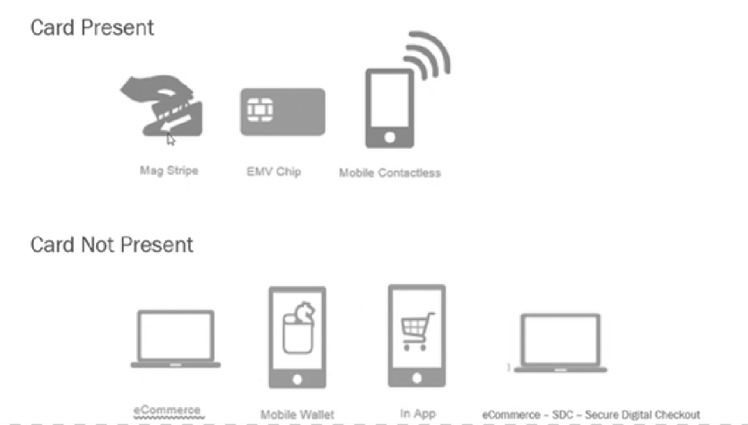

There are different kinds of authorizations possible. Some are card-present, and some are card-not-present. Card-present transactions include methods like Magistrate, EMV chip, and mobile contactless. For card-not-present transactions, there are e-commerce transactions, in-app purchases, and transactions through mobile wallets. All these fall under card-not-present.

ISO 8583 Standard:
ISO 8583 standards, which are used for electronic transactions, particularly in the payment industry. These standards were developed by EMV Co, a company formed by major payment networks like Visa, Mastercard, and others.

ISO 8583 has three main components:

1. Message Type Indicator (MTI)*: This indicates the type of transaction or communication, such as a financial transaction, reversal, or network management message. MTI is a 4-digit code.
2. Bitmap*: This is a binary representation of the data elements present in the message.
3. Data Elements*: These are the actual data fields that contain information about the transaction, such as the card number, expiration date, and transaction amount.

There are different formats of ISO 8583, including:

- 1987 format
- 1993 format
- 2003 format

Different payment networks use different formats, such as:

- Discover Network and Pulse Network use the 1987 format
- Diners Club International uses the 1993 format

These standards enable communication between various entities in the payment ecosystem, including acquirers, issuers, and networks, ensuring that transactions are processed efficiently and securely.
Message Type Indicator (MTI)
Message Type Indicator (MTI) is a four-digit numeric which indicates the overall function of the message.
MTI includes:
- First digit - indicates which ISO 8583 version - from year 1987, 1993 or 2003
Code | Meaning
0xxx | ISO 8583:1987
1xxx | ISO 8583:1993
2xxx | ISO 8583:2003

MTI second - message class - specifies overall purpose of message
MTI second | Message | Usage
x1xx | Authorization message | Determine if funds are available, get an approval but do not post to account for reconciliation. Dual message system (DMS), awaits file exchange or posting to the account.
x2xx | Financial messages | Determine if funds are available, get an approval and post directly to the account. Single message system (SMS), posts directly to the account.
x3xx | File actions message | Used for hot-card, TMS and other exchanges
x4xx | Reversal messages | Reverses the action of a previous authorization.
x5xx | Reconciliation messages | Changes back a previously cleared financial message.
x6xx | Administrative messages | Transmits administrative advice. Often used for failure messages (e.g., message reject or failure).
x7xx | Fee collection messages | Often used for network management functions.
x8xx/x9xx | Reserved by ISO | Used for secure key exchange, logon, echo test and other network functions.
MTI fourth digit – defines location of message source
Code | Meaning
xxx0 | Acquirer
xxx1 | Acquirer repeat
xxx2 | Issuer
xxx3 | Issuer repeat
xxx4 | Other
xxx5 | Other repeat
xxx6 | Reserved by ISO
xxx7 | Reserved by ISO
xxx8 | Reserved by ISO
xxx9 | Reserved by ISO

Key ISO 8583: 93 format message types:
1100/1110 (Authorization & Authorization response)
1120/1130 (Authorization Advice & Acknowledgment)
1200/1210 (Financial Transaction)
1304/1314 (File Action request & response)
1420/1430 (Reversal Advice & Acknowledgment)
1624/1634 (Administrative Advice & response)
1804/1814 (Network Management)
Transaction Flows
ISO 8583: 93 ISO message format basic transaction flows
Standard Authorizations Flow—Issuer Decision
- An Acquirer sends an 1100 Authorizations Request message to Xpress.
- Xpress forwards the 1100 Authorization Request message to the Issuer.
- The Issuer executes its decision making function and returns an 1110 Authorization Request Response message.
- Xpress receives the 1110 Authorization Request Response message and performs proper processing for that message by forwarding it to the Acquirer.
- The Acquirer completes the transaction with the point of service in real time according to the action code contained in the response.
Note: This represents standard Xpress processing. The request is switched to the Issuer for a decision and Xpress transmits the decision to the Acquirer.

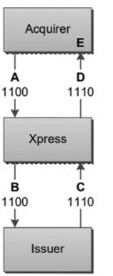
Standard Authorizations Flow Issuer Time-out.
A) Acquirer sends an 1100 Authorizations Request message to Xpress.
(B) Xpress performs the proper processing and routing. Xpress forwards the 1100 Authorization Request message to the Issuer.
(C) Xpress does not receive response from the Issuer within the time period required. Xpress performs Network Stand-in processing and sends an 1130 Authorization Response to the Acquirer.
(D) Xpress sends an 1120 Authorization Advice Message to the Issuer informing them of the Decision made on the transaction.
(E) The Issuer initiates an 1130 Authorization Advice Response message to Xpress.
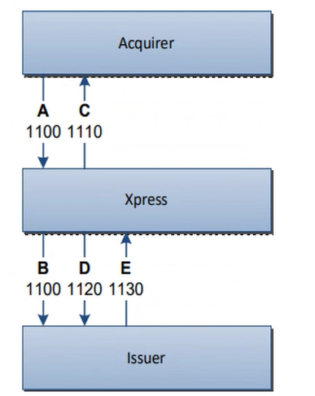

Late Issuer Authorizations Response Xpress Network Stand-in Processing
Effective on 16 April 2021, Acquirer Participants, Service Establishments, and their respective Processors may not use Downtime Authorization Procedures, Stand-In Authorization or Negative File(s), to obtain Authorization decisions for Card Transactions, notwithstanding any terms in the applicable Network Participation Agreement. You must obtain a positive Authorization response for each Card Transaction. If an Authorization Response for a Card Transaction is obtained using Downtime Authorization Procedures, Stand-in Authorization or a Negative File, such Card Transaction may be subject to Noncompliance Fees and Dispute.
(A) Acquirer sends an 1100 Authorizations Request message to Xpress.
(B) Xpress performs the proper processing and routing.
Xpress forwards the 1100 Authorization Request message to the Issuer.
(C) Xpress does not receive response from the Issuer within the time period required. Xpress performs Network stand-in processing and sends an 1110 Authorizations Response message to the Acquirer.
(D) Xpress sends 1120 Authorization advice to Issuer.
(E) Issuer responds with 1130 Authorization advice response.
(F) Xpress receives late 1110 Authorization response from Issuer.
(G) Xpress sends 1420 reversal advice to Issuer.
(H) Issuer sends a 1430 reversal advice response.

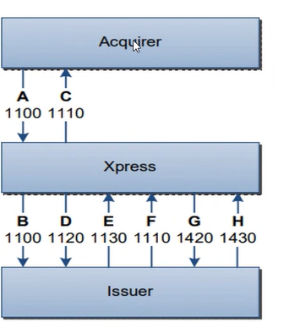

DCI Transaction Switching Overview
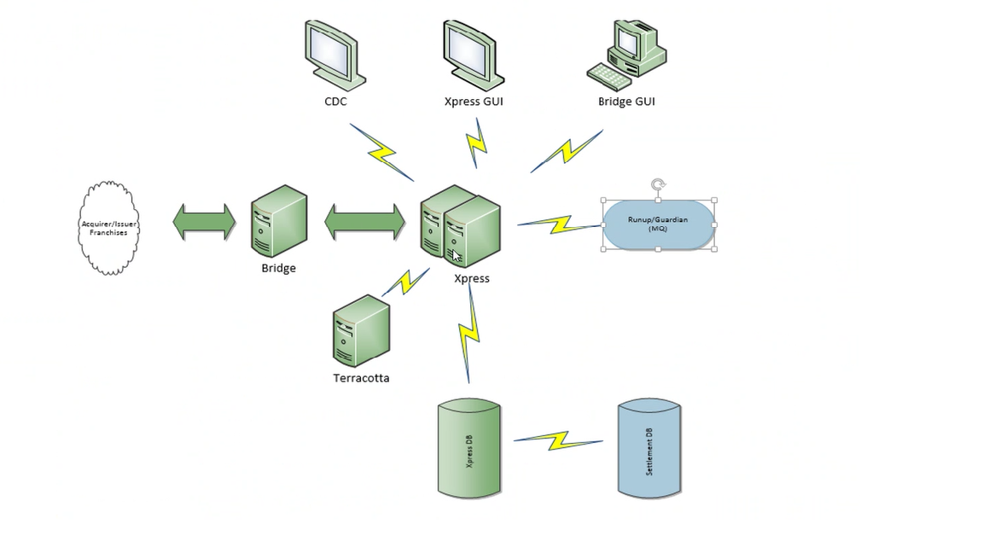

Core Application: Authorization

Peripheral Applications:

1. CDC (Configuration Data Center)*: stores configuration for authorizations, settlement, and disputes process
2. Express GUI (Graphical User Interface): configures connections
3. D-Pop (replaced Bridge GUI): reporting application where participants can log in and access reports

Additional Components:

1. Express Database: settlement processing database that consumes data
2. Hydra Network: DCI (Diners Club International) is now connected with DN (Discover Network) through Hydra

Architecture:

The system architecture involves integration with various applications, including Hydra and the GUI applications (CDC, Express GUI, and D-Pop).

Xpress System Architecture Diagram:

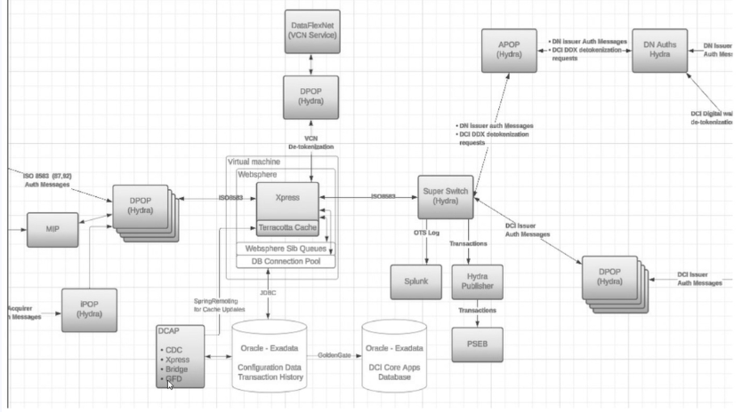

Express Components:
- Express Application: Core application for payment processing.
- Terracotta: Caching layer for Express.
- BM: Platform for Express, includes queues and a DB connection pool using JDBC.
- Express Database: Also known as Extra Data Database.
- Golden Gate Process: Syncs data from Express database to Settlement Database (Core Apps Database).
Hydra Components:
- Gateways: Load balancers, format checkers, protect core applications from external exposure.
- Super Switch: Connected to Splunk (monitoring tool).
- Hydra Publisher: Posts data to the Payment Services Event Bus (PSEB).
- DDX (Discover Digital Exchange): Tokenization service.
Interactions:
- Token Transactions: Express calls Hydra for detokenization.
- VCN (Virtual Card Numbers): Express interacts with DataFlex Net for VCN token transactions.
Other Components:
- CDC: UI application for configuration.
- GFD (Global Fraud Database): UI application using Spring Remoting for caching updates.
- Settlement Database: Database for settlement processing

Xpress Caching Mechanism (Terracotta )
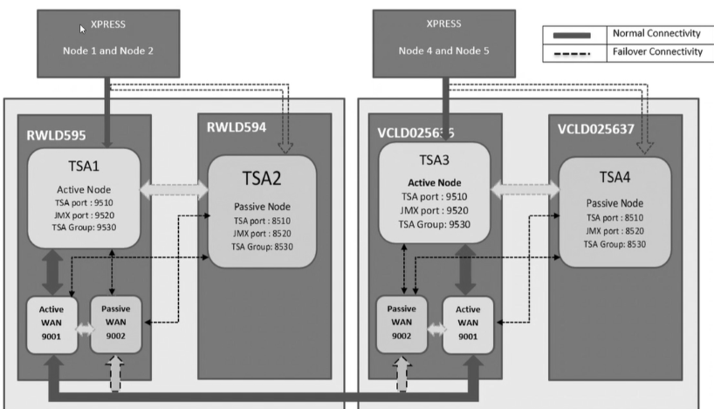

Terracotta Architecture:
- Two Clusters: SSB (Server-Side Batch) and BDC (Batch Data Center) each have a Terracotta cluster with two instances:
  - Active instance (TSA 1 for SSB, TSA 3 for BDC)
  - Passive instance (TSA 2 for SSB, TSA 4 for BDC)
- Data Synchronization: All transactions are sent to the active instance, which syncs data with the passive instance in real-time.
- Van Replication: Terracotta's built-in concept for syncing data between data centers (SSB and BDC).
  - Each data center has an active and passive Van instance.
  - Active Van instances are connected to each other, and passive Van instances are connected to each other, enabling cross-data center sync.
Summary:
- High Availability: If the active instance or Van goes down, the passive instance or Van takes over, ensuring data consistency and availability.
- Data Consistency: Real-time data synchronization between instances and data centers ensures data integrity.
- Testing: This setup is used for testing, including NFT (New Functionality Testing) in a production-like environment.
- Benchmark Environment: The same architecture is replicated in the benchmark environment to ensure consistency and accuracy in testing results.

Perform Functional Testing :
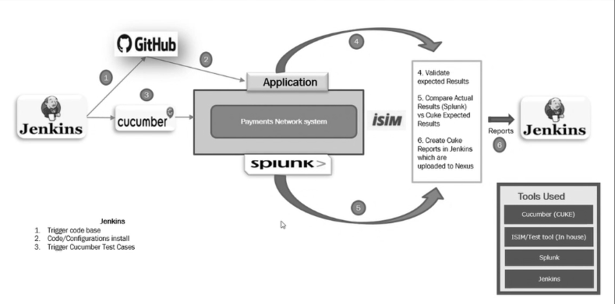

- CICD (Continuous Integration/Continuous Deployment): The codebase is version-controlled(GIT) to ensure smooth integration and deployment.
- Testing Tools:
  - Cucumber: Utilized for specific test cases.
  - Test Tool: Primarily used for functional testing, especially in the Data Center (DC).
Testing Process
- Transaction Simulation: Transactions are sent to the payment network system (Express) to simulate real-world scenarios.
- Integration with Simulator: A simulator acts as an issuer in non-production environments to mimic real transactions.
- Validation: Actual results are compared with expected outcomes to ensure accuracy.
- Reporting: Reports are generated and uploaded to Nexus for further analysis.
- Automated Testing: Both Cucumber and Test Tool are used for functional testing to streamline the process.
- Integration with Monitoring Tools: Monitoring tools are integrated for better visibility and tracking of the testing process.

